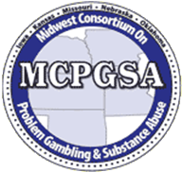
The 2024 Joanna Franklin Scholarship
The 21st Annual Midwest Conference on Problem Gambling and Substance Abuse
June 19-21, 2024

Applicant Letter of Recommendation
Please double click on the grey boxes, type in Microsoft Word and email to the address provided. Handwritten applications will not be processed.

Applicant Name:
Applicant Email:

The Applicant Letter of Recommendation must be completed and emailed to the following no later than April 15, 2024 by 5:00 p.m.
wharwell@oapgg.org
(405) 801-3329)
Please put JF Recommendation in the subject line of the email.

The applicant has requested that you attest to their work in the field of disordered gambling. Please provide any relevant information that would describe the applicant’s commitment, service and potential success in this field. Please limit the recommendation narrative to 200 words or less.

This Letter of Recommendation is provided by:
Name:
Organization Name: Position:
Address:
City: State:
Daytime Phone: Email:
Professional Degrees/Credentials:
How long have you been associated with the applicant:
Do you supervise the applicant? If yes, in what capacity:

