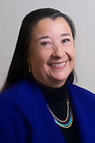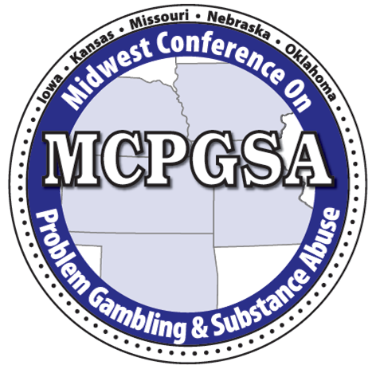
The 2025 Joanna Franklin Scholarship
The 22nd Annual Midwest Conference on
Problem Gambling and Substance Abuse
June 18-20, 2025

The Midwest Consortium on Problem Gambling and Substance Abuse (MCPGSA) representing Kansas, Iowa, Missouri, Nebraska, and Oklahoma is pleased to announce a scholarship opportunity for new professionals in the field of disordered gambling. The Consortium recognizes the need for a continuum of services and we are pleased to provide a learning opportunity for a new professional who is currently working in prevention awareness and education, or clinical services, or research. This is an opportunity to learn from experts in the field and network with other professionals from across the country. The Joanna Franklin Scholarship will be awarded to one professional who is new to the field of disordered gambling (less than three years) and who exhibits commitment, service and potential success as a professional in this field.

You may apply for a scholarship in one of the following:

The prevention scholarship can be awarded to the professional who is currently providing education and raising awareness about disordered gambling; or

The clinical service scholarship can be awarded to the professional who is currently working in a social service agency with gambling clients or concerned others; or

The academic research scholarship can be awarded to one professional who is enrolled in a graduate fellowship and currently conducting disordered gambling research within an academic institution.

This scholarship will support attendance at the 20th Annual Midwest Conference on Problem Gambling and Substance Abuse, June 18-20, 2025. The scholarship includes one conference registration (a $325 value).

This scholarship is in recognition and appreciation of Joanna Franklin’s contribution to the field.

Ms. Franklin was a brilliant pioneer in the field of problem gambling prevention and treatment. She was the first clinician hired by the first state-funded gambling treatment program. She treated problem gamblers and their families from 1979 until her death in October of 2013. Her tributes to the field include founding the Maryland Council on Problem Gambling, a NCPG Goldman Lifetime Award, a member of the NCPG Board of Directors, President of the Association of Problem Gambling Service Administrators, Director of the Center on Problem Gambling at the University of Maryland, and a board member of the International Gambling Counselor Certification Board Institute for Problem Gambling. She designed and delivered clinical training programs in 45 states, 10 Canadian provinces, 31 tribes and 9 countries in addition to providing gambling-specific treatment protocols, clinical training and supervision for national gambling certification. She consulted and trained for the FBI, CIA, Pentagon, the Navy and the Army. She designed and implemented responsible gaming training for state lotteries, race tracks and casinos internationally. Most importantly, she was a mentor and friend to many who have entered the field of problem gambling treatment and prevention.
_________________________________________________________________________________

Scholarship Application Deadline: April 15, 2025 by 5:00 p.m.
Notification Date: April 30, 2025

Please submit scholarship applications via email to Wiley Harwell, MCPGSA President,
wharwell@oapgg.org
(405)-801-3329

The 2025 Joanna Franklin Scholarship Application
Please double click the grey box, fill it in and save the document (Microsoft Word). Email to the address provided. Handwritten applications will not be processed.
I am applying for the following scholarship:

Prevention Education/Awareness Clinical Services Academic Research

Applicant Name:
Place of Employment or Graduate Fellowship: Description of agency/institution:
Position: Last degree completed: List other relevant certifications/licensures:
Work Address:
City: State: Zip:
Daytime Phone: or Cell Phone: E-mail:

Please state your response in 3-4 sentences:
- State why you are applying for this scholarship (please be specific):
- State your expectations of the conference (please be specific):
- Describe how you anticipate utilizing the information gained from the conference:
- State how your work contributes to the field of disordered gambling:
- Would you be willing to participate on a planning committee for the 2026 MCPGSA?
Yes No

If you are applying for the Prevention Education/Awareness Scholarship:
Do you hold a prevention credential? Yes No If yes, what:
Do you hold a disordered gambling or related credential? Yes No If yes, what:
How long have you been working professionally in the field of problem/disordered gambling prevention?
0-12 months 12-24 months 24-36 months
What percent of your time is spent working with communities, youth or special populations?
Please describe the nature of your work as it relates to gambling prevention: (100 words or less)
Aside from paid employment, are you engaged in any other disordered gambling services/activities?
Yes No If yes, please explain

If you are applying for the Clinical Services Scholarship:
What disordered gambling credential do you hold? State: Renewal Date:
How long have you been working professionally in the field of disordered gambling?
0-12 months 12-24 months 24-36 months
What percent of your time is spent working with disordered gambling clients or concerned others?
Please describe the nature your work with this population: (100 words or less)
Aside from paid employment, are you engaged in any other services for this population?
Yes No If yes, please explain

If you are applying for the Academic Research Scholarship:
Do you hold a disordered gambling or related credential? Yes No If yes, what:
How long have you been engaged in disordered gambling research?
0-12 months 12-24 months 24-36 months
Please adequately describe your research as it relates to disordered gambling: (100 words or less)
Aside from paid employment, are you engaged in any other disordered gambling services/activities?
Yes No If yes, please explain

Please send the Letter of Recommendation form for this scholarship to a professional who can attest to your work in the field of disordered gambling. They will complete the form and email separately to the address provided on the form.

